In the past year, eMan has focused on an efficiency strategy. Performance and profit grew
Prague, February 29, 2024 - Prague-based software house eMan has had another successful year. Despite a turnover comparable to last year's, it still achieved a leap in profit. The year 2023 was mainly marked by stabilization of processes and setting the right strategy that will lead to higher performance. There were also changes in the company's management. The preliminary results confirm that this direction has paid off for the company.
(INSIDE INFORMATION)
eMan reports its preliminary financial results. Although it recorded a slight decrease in turnover of CZK 254.4 million, it managed to increase its EBITDA by CZK 11.1 million year-on-year, an increase of more than 60%. Preliminary results before tax amount to CZK 9.9 million, an increase of CZK 8.8 million compared to 2022.
Focus on efficiency and performance
After the period of the waning pandemic and in view of the still active war conflict in Ukraine, the Prague software house focused primarily on stabilizing the company. "In the past year, we focused primarily on streamlining processes. As a result, we were able to reduce operating costs by approximately CZK 24 million. We stagnated in turnover, but we significantly increased EBITDA, thanks to our year-long focus on efficiency," comments Jiří Horyna, CEO and Chairman of the Board.
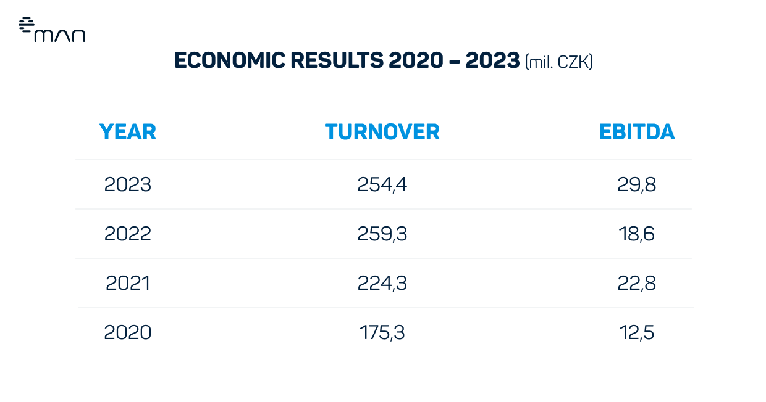
Preliminary figures may still be subject to adjustment as part of the ongoing audit.
"Uncertainty still remains in all markets and of course it has affected us as well. Although we have faced these challenges, I am pleased that we have been able to take measures and adapt to the new conditions and ensure a stable performance. Over the last year we have gained several new clients and successfully fulfilled our plans, which moves us forward and strengthens our position in the market," comments Michal Košek, member of eMan's Board of Directors.
Co-founders back in charge
Last year, Jiří Horyna, who served as CEO until 2021, returned to the company's management board, replacing another of the founders, Michal Košek, who had been in the position since 2022. The original founders returned to operational management and sales, the roles of CEO and chairman were merged and the four founding partners split the agendas. "I am confident that this transformation in leadership will bring positive changes and strengthen our corporate momentum. Through the joint efforts of the founders in operational management and business, we are better able to meet our strategic goals," comments Jiří Horyna, current CEO and Chairman of the Board.
Long-term clients, best references
The company's success is based on several large customers, whether from the financial sector, such as ČSOB, or Cendis from the public sector. Among others, they also have long-standing relationships with Škoda Auto, PPL, Volkswagen and E.ON. New clients include ABB, EP Energy Trading (epet), Česká spořitelna or FutureLife.
At the same time, the company continues to build its technology holding through its investment fund eMan Innovations. In addition to eMan itself, the group of companies includes Zenplanto, Senfina Labs, Modularity, Legend Has It and others. In addition to the Czech Republic, eMan also has an office in Houston, USA, whose position has been growing for several years.
And the outlook for this year? "Of course, we plan to continue to grow and I think we are well on our way. In the first quarter we expect to acquire new customers and launch relatively large projects. However, the growth will not be by leaps and bounds. The goal is to grow continuously and maintain efficiency," concludes Horyna.

***
About eMan:
eMan is a leading Czech software supplier. It specializes in the development of mobile and web applications and related services such as UI/UX design, support and service, outsourcing of IT specialists and provision of consulting. It focuses mainly on clients from the automotive, energy, banking, insurance, industrial and service industries. The quality of developed solutions is confirmed by dozens of awards. eMan operates in the Czech Republic and the United States. Since 2020, the company's shares have been freely traded on the PX Start market of the Prague Stock Exchange and on the RM-System exchange operated by Fio banka.

Media contact:
Nicole Baron
nicole.baronova@abbba.cz
+420 776 204 565
ABBBA Consulting, s. r. o.

Renata Faltejsková
Renata.faltejskova@abbba.cz
+420 774 888 900
ABBBA Consulting, s. r. o.

