From software supplier to technology holding. eMan reports record turnover of CZK 259 million

Prague, 15 March – Despite the economic situation, the Prague software house eMan has achieved great success in recent years. After a successful listing on the Prague stock exchange’s Start market, they managed to establish a number of subsidiaries and thus slowly turn from a development company into a technology holding company.

(INTERNAL INFORMATION)

eMan’s growth did not stop last year, either. According to the preliminary economic results for 2022, the company's turnover reached a record CZK 258.6 million, and thus rose also the planned growth rate. Compared to 2021, when the turnover was CZK 224.3 million, this represents an increase of more than 15 percent. Meanwhile, the year-on-year operating profit EBITDA was CZK 18 million last year, and the profit before tax was CZK 2.98 million.

"I am glad that, despite a number of negative factors that affect our daily lives and business, we managing to grow. At the same time, we have established a number of partnerships and, thanks to this, we can participate in many interesting projects and create synergies across the technology world," said Michal Košek, CEO of eMan.

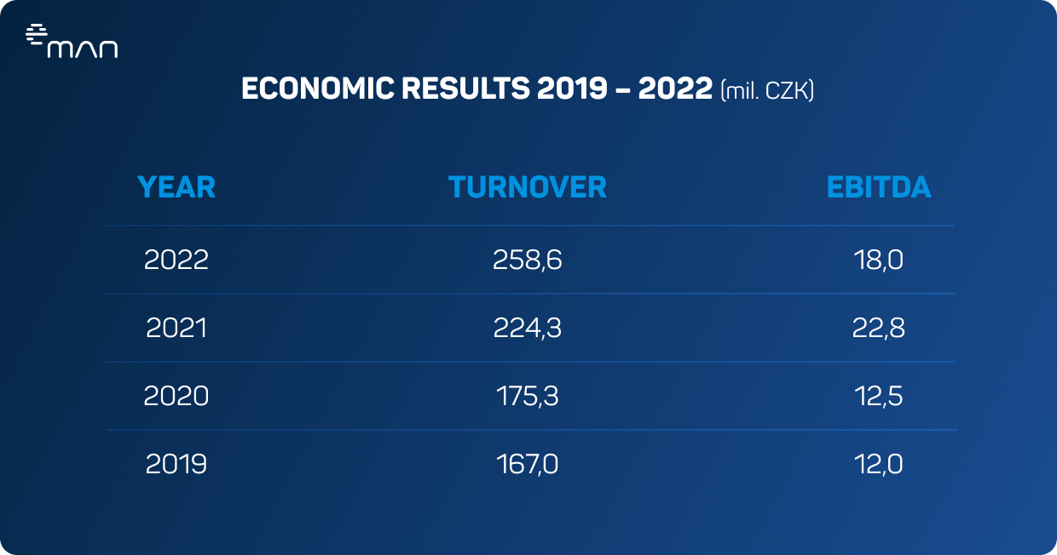

In addition, eMan reached several milestones last year. Through capital investments, it expanded its field of activity far beyond the ‘mere’ development of software and mobile applications, and is slowly turning into a full-fledged technology holding.

Košek added, "new acquisitions and diversification of our business are also part of our plans for the future. The basis of our success is several large customers such as Cendis, Škoda and ČSOB, yet we are, of course, trying to further expand these ranks. We are working on building a technology holding company, which currently boasts seven enterprises. This is also one of the ways in which we are investing our profits back into the development of our company."

Next year (also) in gaming

The company has also had considerable success in the field of gaming, where it is developing Realms of Alterra, under the banner of eMan subsidiary Legend Has It. The game should be available for early access on Steam in the middle of this year. They are also working with Hong Kong-based Hanson Robotics – the company behind the development of the famous humanoid robot Sophia – on the game's AI-based Anigmation technology, which aims to change the entire gaming industry.

The company is also expanding its activities beyond the Czech borders, both in Europe and in the USA, where the Houston office is achieving considerable success.

"Among the goals we have achieved in the past year is the successful pursuit of maximum efficiency, both in production and in other aspects of our business. We were also successful in strengthening our position abroad, particularly in the USA, where we have a subsidiary, but also in the UK and Germany," added Košek.

eMan has its own investment fund

This year, eMan celebrates 13 years on the market. In its early days, the software house primarily specialized in the development of mobile applications for clients in the insurance and energy sectors, but slowly moved into the automotive segment, which is still an important part of its client portfolio. The turning point came in 2020, when the company made history with its listing on the Prague stock exchange’s Start market. At the time, it was the most successful IPO on this market to date – investor interest exceeded the number of shares subscribed by 111 percent.

To add to its growth, a year later, the company decided to back successful projects, investing in the IoT company Hardwario as well as establishing the venture capital fund eMan Innovations. Through this investment fund and more, eMan is flexing its muscles towards a diverse range of sectors. Last year, for example, it announced the creation of a ‘pre-seed’ vehicle, Tasty Capital, for early-stage technology projects.

***
About eMan:
eMan is a leading Czech software supplier specializing in mobile and web application development and related services, such as UI/UX design, support and service, outsourcing IT specialists and consulting. It focuses mainly on clients from the automotive, energy, banking, insurance, industrial and service industries. The quality of our solutions has been confirmed by dozens of awards. eMan operates in the Czech Republic and the United States. Since 2020, the company's shares have been freely traded on the PX Start market of the Prague Stock Exchange on the RM-System, operated by Fio banka.

Media contact:
Nicole Baronová
nicole.baronova@abbba.cz
+420 776 204 565
ABBBA Consulting, s.r.o.

Alena Burešová
alena.buresova@abbba.cz
+420 775 983 842
ABBBA Consulting, s.r.o.

